 | Year 12 Methods  TEST 7 June 2019  TIME: 45 minutes working  Calculator Assumed  44 Marks 6 Questions

Name: _______________________________ Teacher: ___________________________
Note: All part questions worth more than 2 marks require working to obtain full marks.
Question 1 (5 marks)
- Differentiate $x\sin{x}$ (2 marks)

- Hence find $\int_{0}^{\frac{π}{2} }{x\cos{x dx}}$ using the result in(a) above. (3 marks)

Page | 2
Question 2 (3 marks)
Determine the x-coordinates of all points on the graph of $f\left(x\right)=2\cos\left(x\right)+x$ for $-π≤x≤ π$ where the tangent line is horizontal. (Justify your answers)

Question 3 (7 marks)
A survey conducted by a local bank shows that 75% of its customers use an ATM at least once a month.
- Find the probability that in a random sample of 8 customers, at least 75% of them use an ATM machine at least once a month. (2 marks)

- If the random variable X follows a binomial distribution with n=12 and p=0.75, what is the mean of this distribution and what is P$($X$≥$mean$)$? (3 marks)

- If the sample size became very large what would you expect P($X ≥$ mean) to approach? Briefly explain your answer. (2 marks)

Question 4 (10 marks)
The discrete random variable X can only take the values 2, 3 or 4. For these values the cumulative distribution function is defined by
for $x = 2, 3 and 4$, where $k$is a positive constant integer.
- Find the value for $k.$ (3 marks)

- Complete the following table for X. (3 marks)

$$X$$ | $$2$$ | $$3$$ | $$4$$
$$P(X≤x)$$
$$P(X=x)$$

- Hence find $E(X)$ and $SD(X)$. (2 marks)

- Calculate $Var\left(3-2X\right)$ giving your answer to 2 decimal places. (2 marks)

Question 5 (8 marks)
Consider the function where is in radians.
- Sketch on the axes below for on the axes below.
Clearly label undefined points (if any). (3 marks)
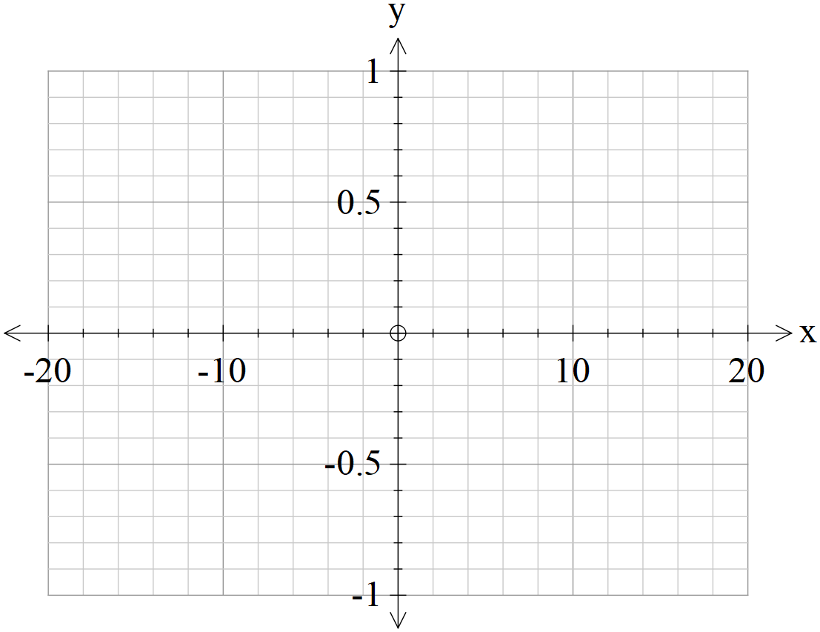
- As approaches zero from the positive side, state the value that approaches.
(1 mark)

- As approaches zero from the negative side, state the value that approaches.
(1 mark)

- Use the above to define a value for as approaches zero, that is the following limit . (1 mark)

It can be shown that .
- Using the fact that and the above results, show that .
(2 marks)

Question 6 (11 marks)
A game is played by throwing two standard six-sided dice into the air once. The sum of the uppermost numbers are added together and if the sum is greater than 8 the player wins $5.
Determine:
- the probability of winning $5 in one game. (2 marks)

- the probability of winning exactly $15 in 5 games. (3 marks)

- the probability of winning at least $15 in at most 5 games. (3 marks)

- the minimum number of games to be played so that the probability of winning at least $15 is greater than 0.47. (Justify) (3 marks)

Working out space

Working out space

